# MAPEAMENTO DE LOJA: MAGALU
- URL de Teste: https://www.magazineluiza.com.br/celulares-e-smartphones/l/te/
- Data da Inspeção: 28/29/2026

##1. Valores de Referência (Gabarito Visual)
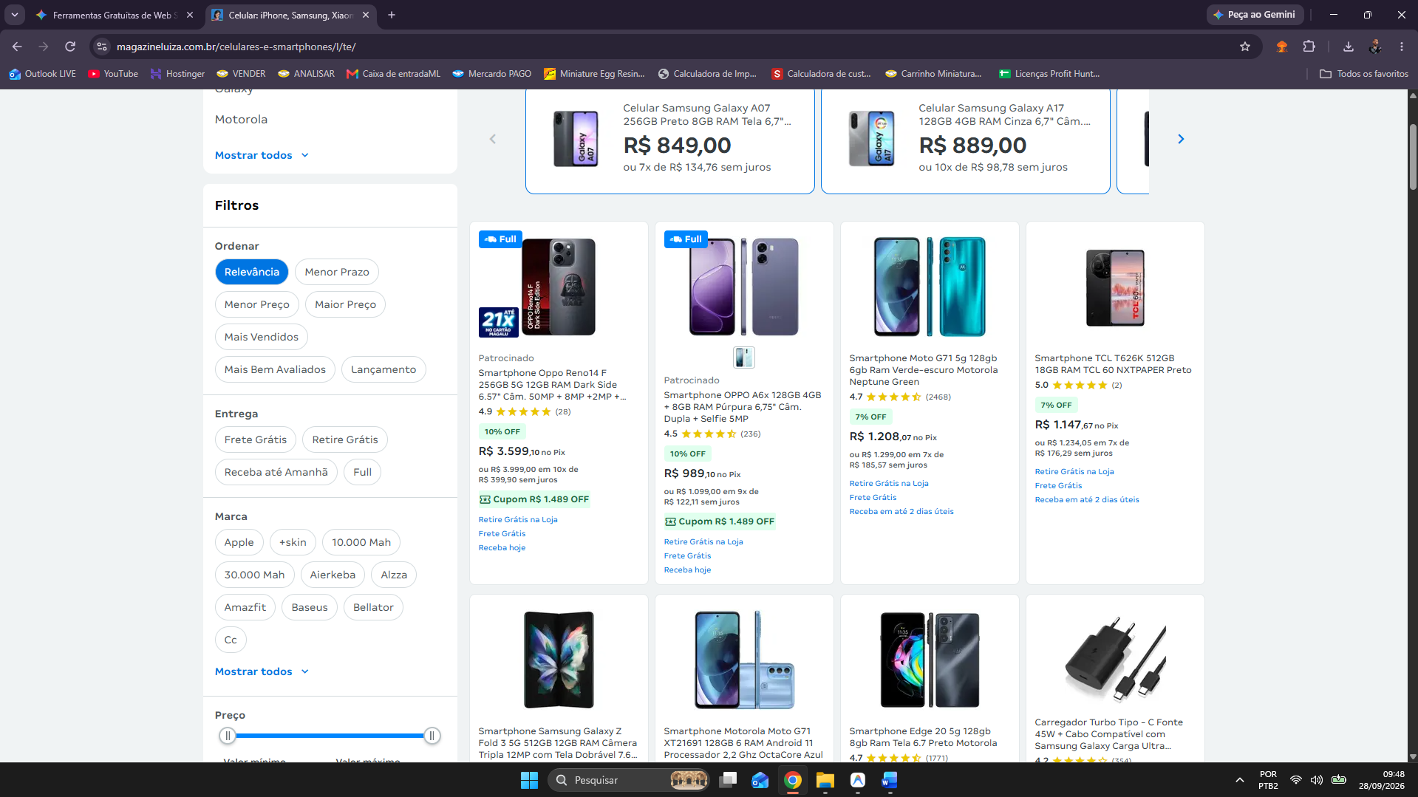

- Preço Original (De): inesistente
- Preço com Desconto (Por): R$ 3599,10
- Porcentagem de Desconto: 10% OFF

<a aria-labelledby=":R1g5selrel6:-title :R1g5selrel6:-sponsored :R1g5selrel6:-tag-0 :R1g5selrel6:-tag-1 :R1g5selrel6:-tag-2 :R1g5selrel6:-tag-3" class="relative h-full" data-testid="product-card-link" href="/smartphone-oppo-reno14-f-256gb-5g-12gb-ram-dark-side-6-57-cam-50mp-8mp-2mp-selfie-32mp/p/240862200/te/op14/?seller_id=magazineluiza"><div class="pb-xsm absolute flex items-center justify-between z-[1] w-full absolute" data-testid="product-card-header"><div><div class="tag font-2xsm-bold" data-testid="tag" position="header"><i class="icon icon-entrega-2-dias font-xsm-regular" data-testid="product-card-header-icon-entrega-2-dias"></i>Full</div></div></div><div class="flex-1 flex flex-col min-w-0 !bottom-[0]" data-testid="wrapper"><div class="relative h-[137px] mt-xsm max-h-[137px] max-w-full object-contain !w-full" data-testid="product-card-media-content"><img alt="Imagem do produto" class="object-cover h-[100%] w-[100%] rounded-md !object-contain max-h-[137px] max-w-full object-contain !w-full" data-testid="product-card-media" decoding="async" draggable="false" fetchpriority="high" height="137" loading="eager" sizes="(min-width: 1280px) 25vw, (min-width: 1024px) 33vw, (min-width: 640px) 50vw, 100vw" src="https://a-static.mlcdn.com.br/206x137/smartphone-oppo-reno14-f-256gb-5g-12gb-ram-dark-side-6-57-cam-50mp-8mp-2mp-selfie-32mp/magazineluiza/240862200/8f8ebf830324f1e6fa0f37b50b966c59.jpg" width="206"><img alt="fazum21" class="absolute bottom-[0] w-[54px] h-[41px]" data-testid="product-card-badge" decoding="auto" height="44" loading="lazy" src="https://assets.mlcdn.com.br/selo-ml/60x44/9a91b0e6-7a99-11ef-983d-1a6882f79d62.png" width="60"></div><div class="align-center mt-sm gap-xsm flex w-full flex-row justify-center flex-wrap" data-testid="container-attribute-list"></div><div class="pt-xsm" data-testid="card-content"><p class="mb-2xsm text-on-surface-4 font-2xsm-regular" data-testid="product-card-sponsored" id=":R1g5selrel6:-sponsored">Patrocinado</p><h3 data-testid="product-card-title" class="mb-2xsm overflow-hidden break-words text-on-surface-2 font-2xsm-regular line-clamp-3" id=":R1g5selrel6:-title">Smartphone Oppo Reno14 F 256GB 5G 12GB RAM Dark Side 6.57" Câm. 50MP + 8MP +2MP + Selfie 32MP</h3><div class="mb-md flex flex-wrap items-center gap-2xsm mb-xsm" color="primary" data-testid="product-card-rating"><span class="text-on-surface-2 font-xsm-medium !font-2xsm-medium text-on-surface-2" data-testid="rating-score">4.9</span><ol class="no-hover relative rating rating-sm" data-testid="rating-list"><li aria-label="5 estrelas" class="rating-item rating-full checked flex" data-testid="rating-li-5"></li><li aria-label="4 estrelas" class="rating-item rating-full flex" data-testid="rating-li-4"></li><li aria-label="3 estrelas" class="rating-item rating-full flex" data-testid="rating-li-3"></li><li aria-label="2 estrelas" class="rating-item rating-full flex" data-testid="rating-li-2"></li><li aria-label="1 estrelas" class="rating-item rating-full flex" data-testid="rating-li-1"></li></ol><span class="text-on-surface-3 font-3xsm-regular" data-testid="rating-label">(28)</span></div><div style="transform-origin:left top"><div class="grid grid-cols-[min-content] gap-x-3xsm items-baseline [grid-template-areas:&quot;original_original&quot;_&quot;discount_discount&quot;_&quot;final_method&quot;_&quot;installment_installment&quot;] break-words grid items-baseline break-words" data-testid="product-card-price" lang="pt-BR"><div class="tag bg-green-600 text-on-green-600 font-3xsm-bold first-letter:uppercase w-max mb-3xsm col-span-full mt-[0] w-max [grid-area:discount]" data-testid="tag" aria-label="10% off">10% OFF</div><p aria-labelledby="price-final-label-255" class="text-on-surface-2 font-xlg-bold md:font-2xlg-bold [grid-area:final] inline-flex items-baseline gap-x-1xsm flex items-baseline gap-1 text-on-surface-2 !font-lg-bold md:!font-md-bold gap-x-1xsm inline-flex items-baseline" data-testid="product-card-price-final"><span class="sr-only" id="price-final-label-255">Preço R$&nbsp;3.599,10</span><span aria-hidden="true" class="whitespace-nowrap"><span class="text-on-surface-1 leading-none font-sm-medium" data-testid="price-value-currency">R$</span> <span class="text-on-surface-1 leading-none font-sm-medium" data-testid="price-value-integer">3.599</span><span class="text-on-surface-1 leading-none font-3xsm-medium" data-testid="price-value-split-cents-decimal">,</span><span class="text-on-surface-1 leading-none font-3xsm-medium" data-testid="price-value-split-cents-fraction">10</span></span></p><span aria-label="no Pix" class="text-on-surface-3 font-xsm-regular whitespace-nowrap [grid-area:method] text-on-surface-3 font-xsm-regular flex-shrink-0 whitespace-nowrap !font-3xsm-medium" data-testid="product-card-price-method">no Pix</span> <span aria-labelledby="price-installment-label-:Rm77g5selrel6:" class="[grid-area:installment] text-on-surface-3 font-xsm-regular text-on-surface-3 !font-2xsm-regular mb-2xsm !mt-2xsm [grid-area:installment] !font-3xsm-medium !my-[0]" data-testid="product-card-price-installment"><span class="sr-only" id="price-installment-label-:Rm77g5selrel6:">Ou R$&nbsp;3.999,00 em 10x de R$&nbsp;399,90 sem juros</span><span aria-hidden="true">ou<!-- --> <!-- -->R$&nbsp;3.999,00<!-- --> em <!-- -->10<!-- -->x<span> de </span><br>R$&nbsp;399,90<!-- --> <!-- -->sem juros</span></span></div></div><ol class="[&amp;&gt;*:first-child]:mt-xsm" data-testid="product-card-tags"><li><div class="tag-sm tag text-interaction-default items-center p-[0] bg-green-600 text-on-green-600 font-3xsm-bold lg:font-2xsm-bold gap-2xsm mb-2xsm p-3xsm lg:!py-2xsm lg:!px-3xsm mt-[0] " data-testid="tag" id=":R1g5selrel6:-tag-0"><i class="icon icon-cupom-journey"></i>Cupom R$&nbsp;1.489 OFF</div></li><li><div class="tag-sm tag tag-inverted text-interaction-default items-center p-[0] font-3xsm-regular mt-2xsm " data-testid="tag" id=":R1g5selrel6:-tag-1">Retire Grátis na Loja</div></li><li><div class="tag-sm tag tag-inverted text-interaction-default items-center p-[0] font-3xsm-regular mt-2xsm " data-testid="tag" id=":R1g5selrel6:-tag-2">Frete Grátis</div></li><li><div class="tag-sm tag tag-inverted text-interaction-default items-center p-[0] font-3xsm-regular mt-2xsm " data-testid="tag" id=":R1g5selrel6:-tag-3">Receba hoje</div></li></ol></div></div></a>
selector e xpach preço:
#category > section > div > div.flex.flex.flex-col.xlg\:flex-row.xlg\:w-full.xlg\:min-w-\[0\] > div.flex.\!block.xlg\:\!flex.xlg\:min-w-\[0\].xlg\:flex-1.xlg\:flex-col.xlg\:overflow-hidden > div.px-md.pb-xsm.xlg\:w-full.xlg\:overflow-x-auto.flex.flex-col > div > div:nth-child(1) > div > a > div.flex-1.flex.flex-col.min-w-0.\!bottom-\[0\] > div.pt-xsm > div:nth-child(4) > div > p > span.whitespace-nowrap > span:nth-child(2)

//*[@id="category"]/section/div/div[3]/div[2]/div[3]/div/div[1]/div/a/div[2]/div[3]/div[2]/div/p/span[2]/span[2]

Selector e xpach desconto%:

#category > section > div > div.flex.flex.flex-col.xlg\:flex-row.xlg\:w-full.xlg\:min-w-\[0\] > div.flex.\!block.xlg\:\!flex.xlg\:min-w-\[0\].xlg\:flex-1.xlg\:flex-col.xlg\:overflow-hidden > div.px-md.pb-xsm.xlg\:w-full.xlg\:overflow-x-auto.flex.flex-col > div > div:nth-child(1) > div > a > div.flex-1.flex.flex-col.min-w-0.\!bottom-\[0\] > div.pt-xsm > div:nth-child(4) > div > div

//*[@id="category"]/section/div/div[3]/div[2]/div[3]/div/div[1]/div/a/div[2]/div[3]/div[2]/div/div

